**United States Department of Agriculture**

Food and Nutrition Service

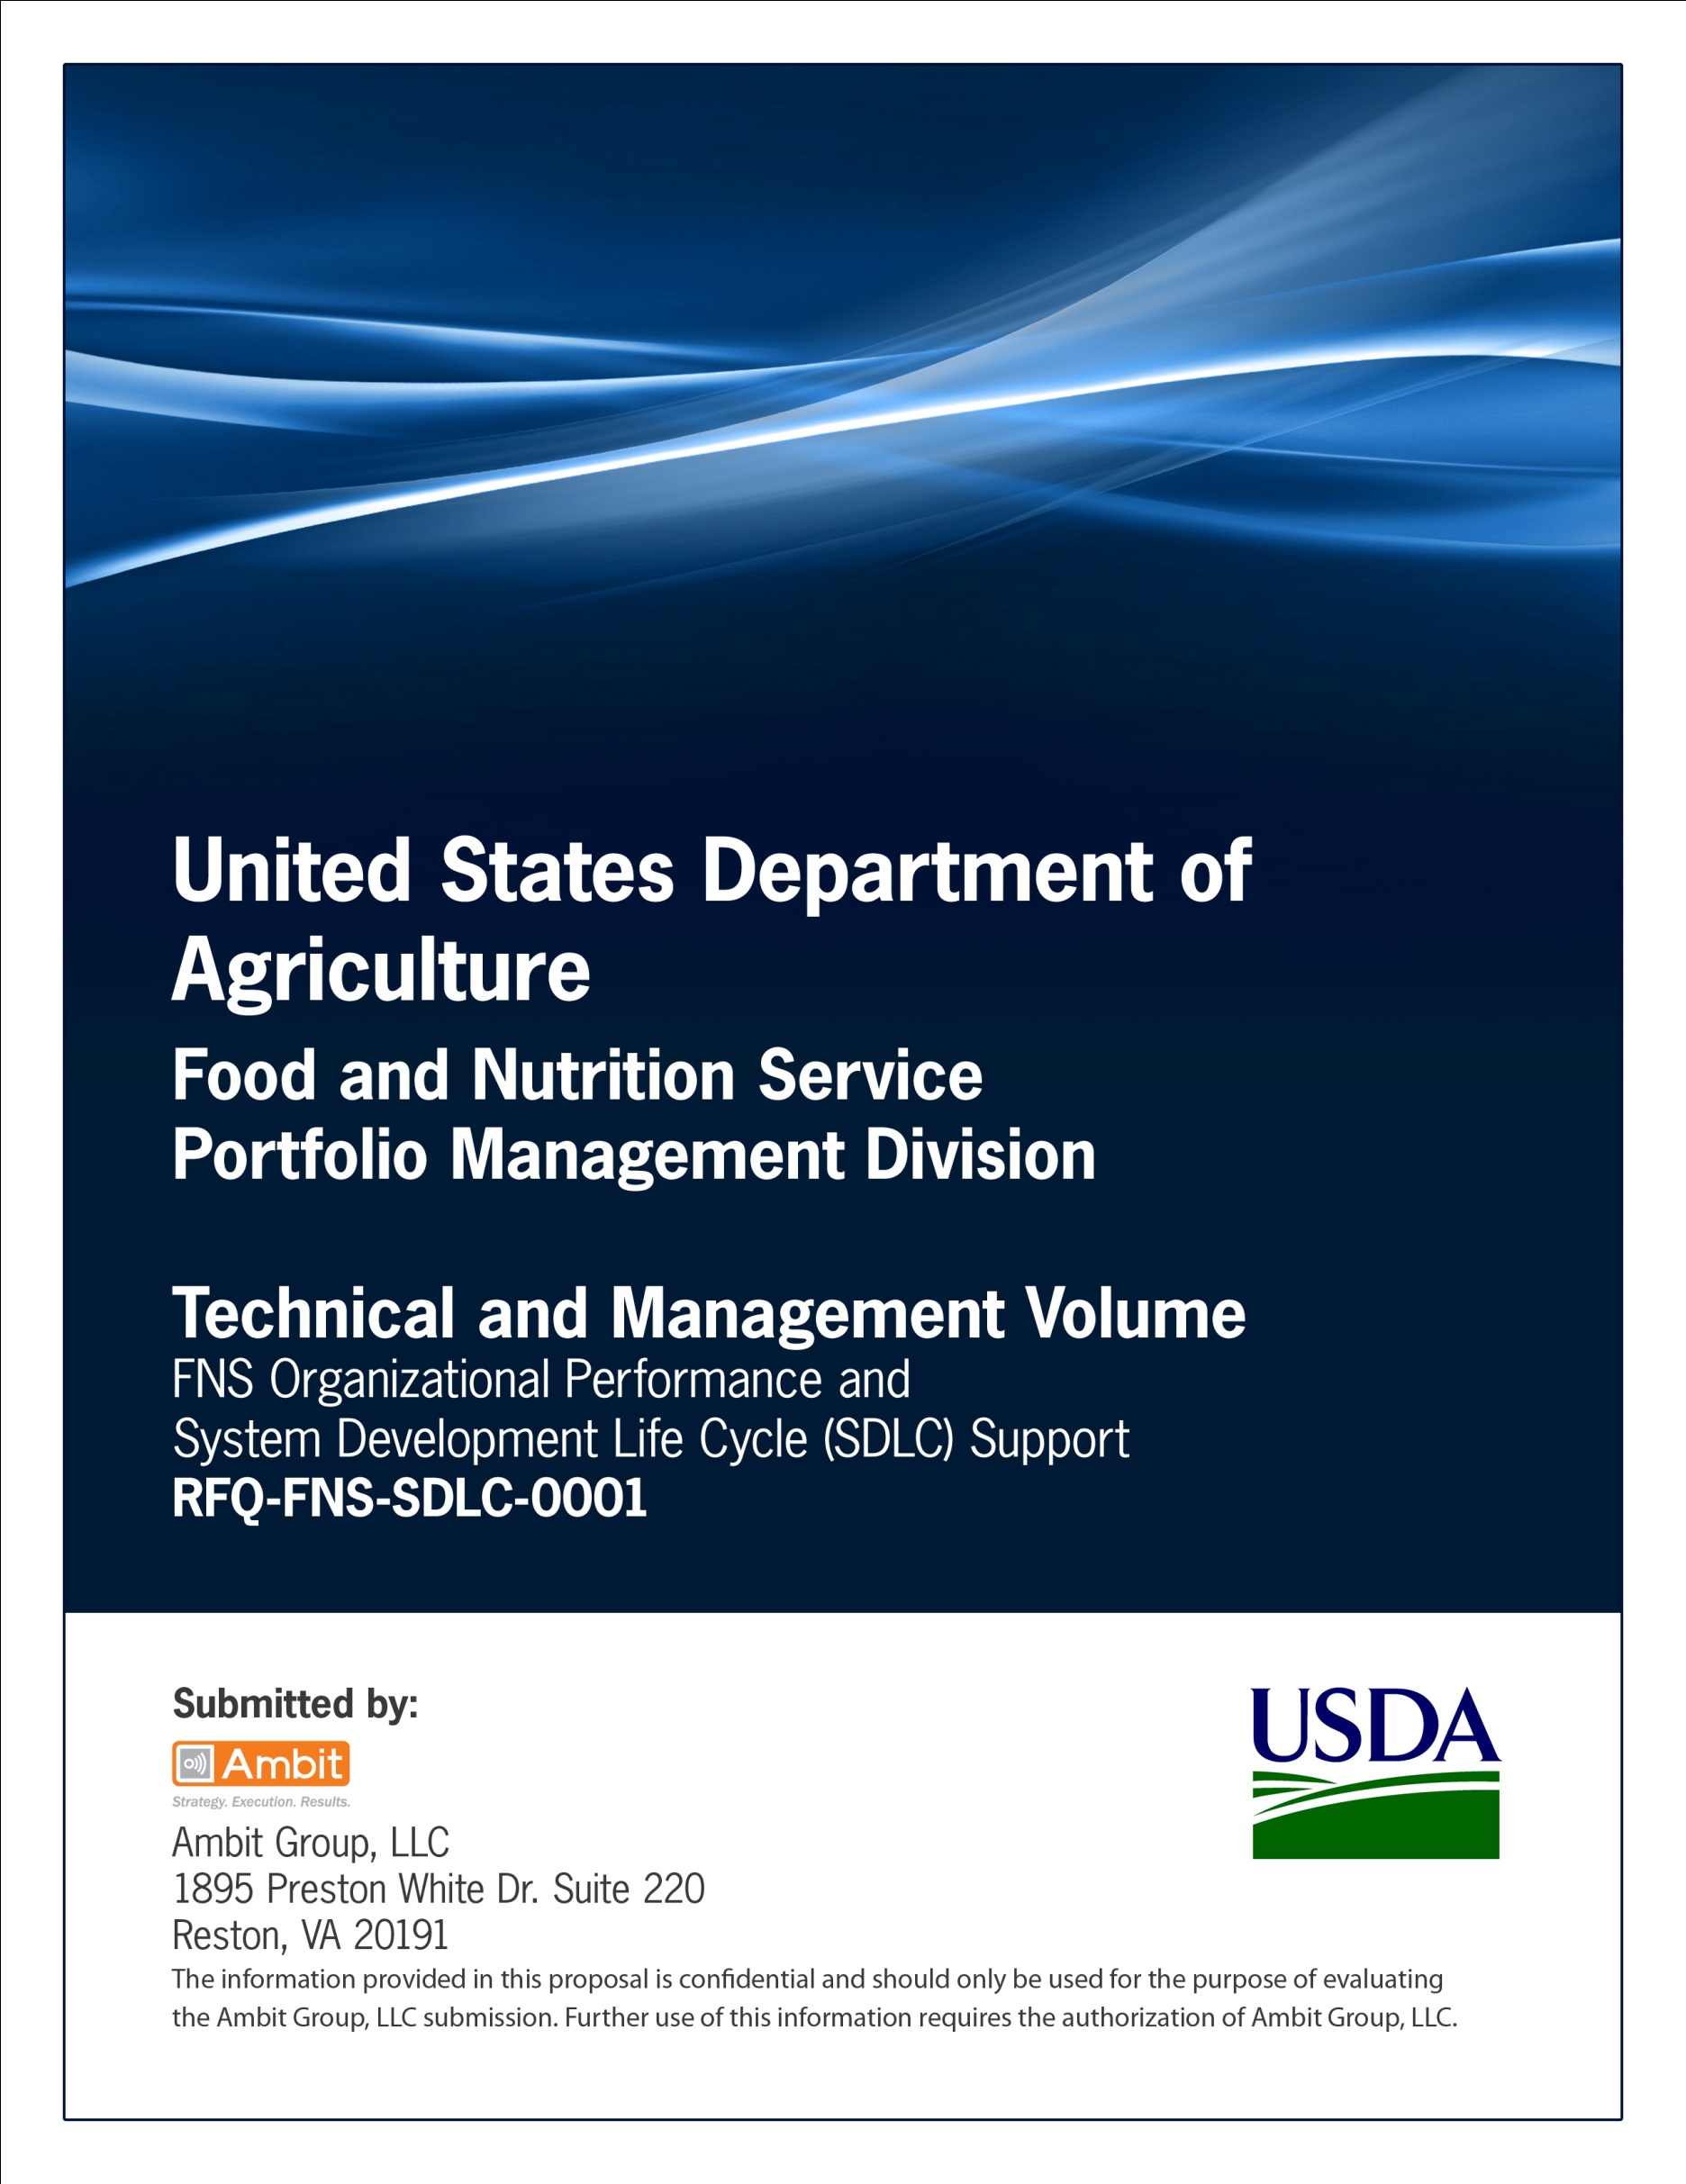

**FNS Office of Information Technology**

**Portfolio Management Division (PMD)**

**FNS Integrated Project Team Charter Template**

**for**

**[Project or System Name]**

**Version 1.1**

September 09, 2013

**Revision History**

|  |  |  |  |
| --- | --- | --- | --- |
| **Version** | **Date** | **Author** | **Change Description** |
| 1.0 | 03-12-2013 | IT Governance Branch (ITGB) | Created the document. |
| 1.1 | 09-09-2013 | IT Governance Branch (ITGB) | Re-formatted the document. |
| 1.2 |  |  |  |
| 1.3 |  |  |  |

**Contact Information**

|  |  |
| --- | --- |
| **Area of Concern** | **Contact Person** |
| IT Governance Lead | Kevin Russ |
| SDLC Coordinator | Syed Jaffery |
| ITIRB Coordinator | Sunny Dilawari |
| Portfolio Management Division Director, Chief Portfolio Officer | Jacqueline Butler |
| Program Management Branch Chief | Allison Willcox |

Contents

Glossary 4

1. Need, Purpose, Scope 5

2. Outcomes, Outputs and Performance 5

3. Authority 5

4. Key External Processes 5

5. Key Stakeholders 5

6. Membership 5

7. IPT Functions 5

8. Decision Process 5

9. Meeting Management 5

10. Charter Expiration 5

Appendix A: IPT Roles Matrix 6

Appendix B: References 7

Approvals/Signatures 8

# Glossary

| **Acronym** | **Description** |
| --- | --- |
|  |  |
|  |  |
|  |  |
|  |  |
|  |  |
|  |  |
|  |  |
|  |  |

# Need, Purpose, Scope

Specify the Need, Purpose and Scope.

# Outcomes, Outputs and Performance

Specify the outcomes, outputs and performance.

# Authority

Specify the Authority for the investment.

# Key External Processes

Identify key external processes.

# Key Stakeholders

Identify the key stakeholders for the investment.

# Membership

See Appendix A – IPT Roles Matrix.

# IPT Functions

Specify the IPT Functions.

# Decision Process

Specify the Decision Process.

# Meeting Management

Specify the Meeting Management process.

# Charter Expiration

Specify the Charter Expiration Date.

# Appendix A: IPT Roles Matrix

|  |  |  |
| --- | --- | --- |
| **Project Name:** | | |
| **IPT Membership** | **Name** (if vacant, enter "VACANT") | **Email** |
| **Core Members** | | |
| Project Lead (co-chair) |  |  |
| Business Lead (co-chair) |  |  |
| Technical Representative |  |  |
| Security Representative |  |  |
| Contracting Office Technical Representative (COTR) |  |  |
| **Associate Members** | | |
| SDLC Governance Representative |  |  |
| Network Representative |  |  |
| Records Management |  |  |
| Telecommunications Representative |  |  |
| Operations & Maintenance Representative |  |  |
| Contracting Officer |  |  |

# Appendix B: References

Insert the name, version number, description, and physical location of any documents referenced in this document. Add rows to the table as necessary.

The following table summarizes the documents referenced in this document.

|  |  |  |
| --- | --- | --- |
| **Document Name** | **Description** | **Location** |
| Document Name and Version Number | Document description | URL or Network path where document is located |
|  |  |  |
|  |  |  |

# Approvals/Signatures

The undersigned acknowledge that they have reviewed the [name of document] document and agree with the information presented within this document. Changes to this document will be coordinated with, and approved by, the undersigned, or their designated representatives.

|  |  |  |  |
| --- | --- | --- | --- |
| Signature: |  | Date: |  |
| Print Name: |  |  |  |
| Title: |  |  |  |
| Role: | [Project or System Name] Project Manager |  |  |
|  |  |  |  |
| Signature: |  | Date: |  |
| Print Name: |  |  |  |
| Title: |  |  |  |
| Role: | [Project or System Name] Business Owner |  |  |
|  |  |  |  |
| Signature: |  | Date: |  |
| Print Name: |  |  |  |
| Title: |  |  |  |
| Role: | Organization’s Approving Authority |  |  |